Causative Predicate

✅ What Is a Causative Predicate?
# Source: AI Source: Provided by: [Data Path: Persons Table -> ID Column: 1, Name_En Column: Motasem Essam] -> From: [ChatGPT] on [8/4/2025]
A Causative Predicate is a predicate in which the subject causes someone or something else to perform an action or experience a change of state.
It uses causative verbs such as make, have, get, let, or cause.

🔸 Key Features:
# Source: AI Source: Provided by: [Data Path: Persons Table -> ID Column: 1, Name_En Column: Motasem Essam] -> From: [ChatGPT] on [8/4/2025]
- The subject does not perform the action directly, but makes it happen.
- The action is often performed by another person or agent.
- Involves two participants:
  - The causer (subject)
  - The doer (usually an object)
- Often includes a bare infinitive (make him cry) or to-infinitive (get him to cry).

🔸 Common Causative Verbs:
# Source: AI Source: Provided by: [Data Path: Persons Table -> ID Column: 1, Name_En Column: Motasem Essam] -> From: [ChatGPT] on [8/4/2025]
- Make – force or compel
- Have – instruct or arrange
- Get – persuade or convince
- Let – allow
- Cause – result in something happening

🔸 Examples of Causative Predicates:
# Source: AI Source: Provided by: [Data Path: Persons Table -> ID Column: 1, Name_En Column: Motasem Essam] -> From: [ChatGPT] on [8/4/2025]
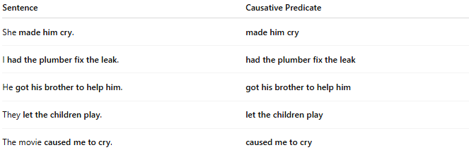
Sentence | Causative Predicate
She made him cry. | made him cry
I had the plumber fix the leak. | had the plumber fix the leak
He got his brother to help him. | got his brother to help him
They let the children play. | let the children play
The movie caused me to cry. | caused me to cry

🔸 Compare With Verbal Predicate:
# Source: AI Source: Provided by: [Data Path: Persons Table -> ID Column: 1, Name_En Column: Motasem Essam] -> From: [ChatGPT] on [8/4/2025]
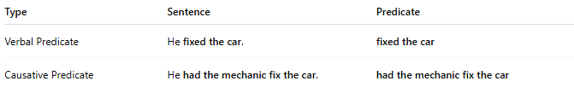
Type | Sentence | Predicate
Verbal Predicate | He fixed the car. | fixed the car
Causative Predicate | He had the mechanic fix the car. | had the mechanic fix the car

